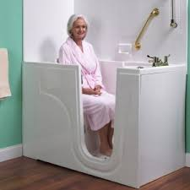
Support HB16 - 1065
Tax Credit for Home Health Care

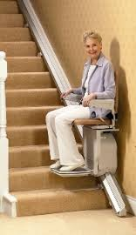
HB16 – 1065 Summary
HB16 – 1065 creates an income tax credit for durable medical equipment (pg 1), tele-health equipment, home modifications (pg 2), or home health care services so that qualifying seniors can stay in their home rather than moving into an assisted living center.
Reasons for the Bill
The numbers of Coloradans who are 65 and older will more than double from 700,000 in 2014 to 1.5 million in 2040. According to data from the Employee Benefits Research Institute, 48% of workers over 45 have savings and investments of less than $25,000, which would be exhausted in 6 months in a nursing home or one year in an Assisted Living Facility. HB16 – 1065 aims to keep seniors in their home by allowing the necessary home modifications, home care services and tele-health equipment rather than moving to a nursing facility.
- Clients living at home average Medicaid cost is $16,100 per year. (FY 13-14)
- Clients living in an Assisted Care Facility, average Medicaid cost is $19,400 per year. (FY 13-14)
- Clients living in a Nursing Home, average Medicaid cost is $58,800 per year. (FY 13-14)

**Changes to this Bill**
- JBC Trigger requiring 6% income Growth required for any year of implementation (Pg,6 Line, 19)
- Tax Credit for Medically necessary Home Modifications (Pg,4 Line,23)
- Home Healthcare Services: Credit beginning 2018
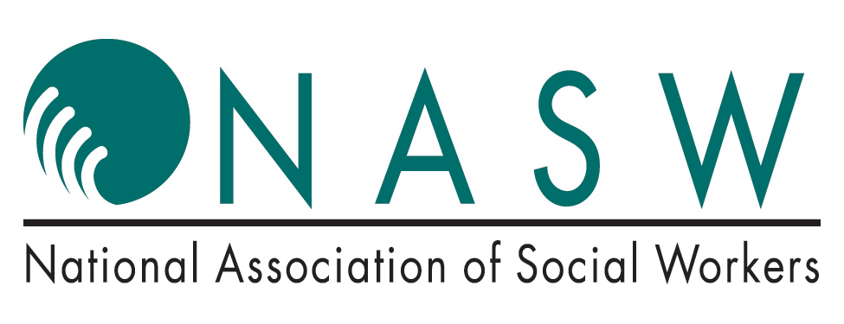
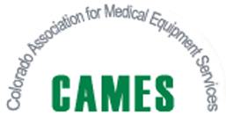
- DME or Tele-health equipment beginning 2020

